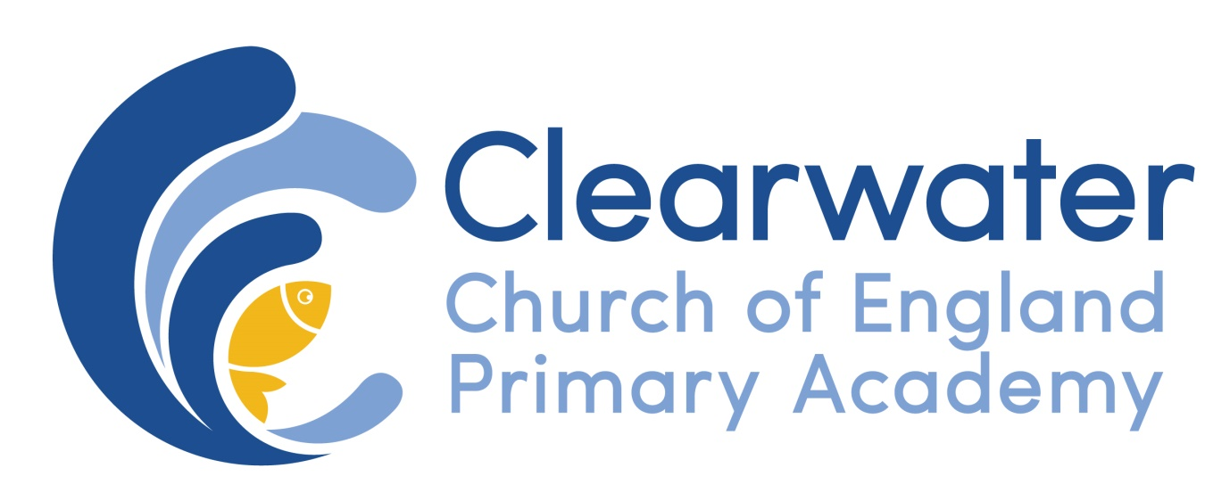

EYFS
Assessment, Marking and Feedback Policy

Review Cycle; Annual
Responsible group: Headteacher, EYFS Lead and LGB
Implementation date: September 2017
Next Review Date: September 2018

At the beginning of EYFS at Clearwater C of E Academy assessment will mainly take the form of observation, careful open-ended questioning and verbal feedback. This will feed into the EYFS pupil profile will be recorded in the child’s learning journey.
Assessment will be entered into target tracker in accordance with the school and DGAT’s timetable data collection timetable.
Observations from all staff are used to inform planning and create a picture of pupils’ competencies. Information from home is part of this process with a two-way flow of information between the setting and home creating a whole picture of the child.
As the year progresses the expectation with regard to more formal marking and feedback will increase alongside the continuation of observations. The purpose of accurate assessment, feedback and marking is to: -
- Assess the pupils understanding, learning, attainment and progress and plan next steps
- Communicate these next steps to the pupil through addressing misconceptions and scaffolding future learning
- Identify any barriers and find creative solutions to ensure all children have access to quality teaching regardless of starting points
- Make accurate summative judgement (EYFS Profile) based on detailed knowledge of each pupil at the end of the year
- Inform conversations with parents using accurate and up to date information

Within the EYFS all marking should relate to the learning objective/ELG. Where child initiated learning encompasses another aspect this can also feed into the assessment profile for this child. When the children progress to formal recording teacher marking will be carried out in green pen. Marking and assessment may be done in the following ways with an expectation that live marking will be used most frequently, as it is the most effective with this age group:
- Verbal Feedback (VF)
- Written feedback, ticks and other symbols including stamps and stickers
- Informal, peer or self-marking, supervised by the teacher
As children’s ability to scribe increases the marking may include
- Two stars and a wish at the end of a piece of work
- Feedback may be written or pictorial however it must be verbally explained to the child
- Where only verbal feedback has been given, the teacher must record this with a VF on the child’s work
- Written feedback must be brief, matched to the learning objective or the individual child’s target.
- Where a ‘wish’ has been stated to improve or extend a pupil’s work, the child must be given a further learning opportunity with time to act on this
- Time should be used where appropriate to review marking of previous work at the beginning of a lesson using a ‘purple polishing pen’ in a five minute feedback focus (FFF)
- Once the formation of number has been taught it will be corrected if incorrectly formed or reversed.
- As mathematics becomes more sophisticated calculations should be corrected with the child (using a purple polishing pen) and misconceptions addressed.
- Phonic patterns are corrected depending on the Letters and Sounds phase the child is working within.
- Key word spellings are corrected if the child has been taught them and they are practiced. They are expected to be spelt correctly in future
- Handwriting may also be corrected where appropriate to do so, for example after the formation of a letter has been taught. Where the development of a child’s fine motor skills hinders the use of cursive script adaptations will be made.
- Teachers are expected to use a tick to signify a correct response and a dot to show that a mistake has been made/correction is required.

