

https://www.gloucesterrocks.co.uk/
Country Parks in Gloucester
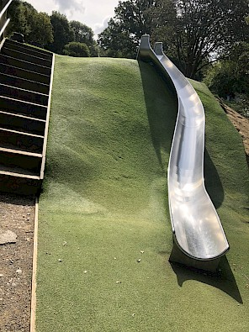
Robinswood Hill Country Park
The bottom of Robinswood Hill features a little play area with a climbing frame, wooden aparatus and a big slide. There are lots of benches for picnics, a decent sized free car park, and a café. The café is run by Gloucestershire Wildlife Trust and is open every day during school holidays & public holidays , 11am-5pm, and every weekend from Sat 31st March – Sun 2nd Sept, 11am-5pm. If you do then fancy a walk up the hill, there are great views of the Severn Bridge, the Malvern Hills, and the Black Mountains.

St James Park
is a pretty well equipped play area. Alongisde an enclosed play area, there is also a basketball hoop, a few pieces of exercise equipment, and a relatively fenced-in green space. The play area is packed with two slides, two swing sets, and a number of climbing apparatus and sit-ons. Attached to the park is St James City Farm which has free entry, so you could always St James Park

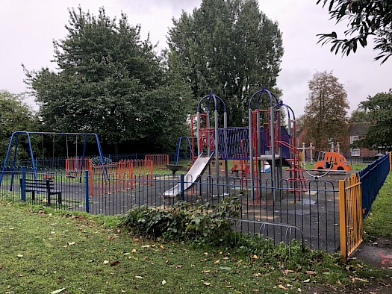
Barnwood Arboretum
Whilst not strictly a park or play area, Barnwood Arboretum makes a great place for a leisurely stroll with little ons. It has a number of quirky trees to expore, a duck pond, wild flowers growing seasonally, and on occasion a rogue friendly sheep or two! It was even nominated one of the UK's Best Parks in 2017, so it is well worth a visit

Things to do on a Rainy Day in Gloucester

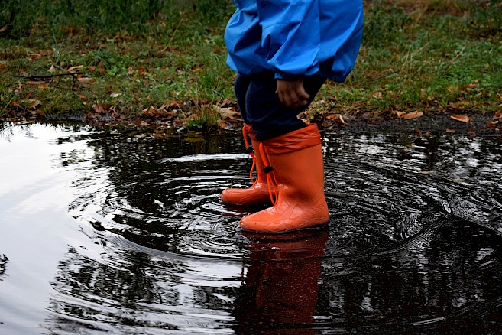
As we move out of winter, this time of year begins to see natural beauties like the snowdrops appearing. However, it also often brings with it lots of rain. We have compiled a collection of local activities to keep you and your family entertained, even if it is pouring outside.

The Jet Age Museum
Budding pilots will love to explore aircrafts, engines, cockpits, and a whole host of other exciting aviation equipment at The Jet Age Museum. Many of the pieces within it are interactive, allowing children to climb aboard real cockpits and airliners. The Jet Age museum is open Saturdays, Sundays and bank holiday Mondays from 10am – 4pm.

Gloucester Cathedral
Gloucester Cathedral sits in the heart of Gloucester and and offers a wealth of history and immense beauty. It also has a cafe with a varied menu offering something for everyone and celebrates local produce from in and around Gloucestershire. Gloucester Cathedral is open 365 days a year and the usual opening times are between 7.30am and 6.00pm.

Nature in Art
Nature in Art is a museum and art gallery dedicated exclusively to fine, decorative and applied art inspired by nature. The collection reflects the exciting diversity of work produced by artists inspired by nature through the centuries and has regularly changing displays. The museum is open Tuesday - Sunday from 10am to 5pm.

JDR Karting
Thrill seekers will have a great day out at JDR Karting. With indoor go-karting suitable from age 4, they also offer Laser Tag and a Segway experience both suitable from age 6 up to adult. JDR Karting is open everyday with varyng timings, including late openings. Prebooking is required.

The National Waterways Museum Gloucester
The Waterways Museum is situated in Gloucester Docks and boats fun interactive exhibits showcasing the fascinating 200-year history of the docks. The Museum is open Tuesday to Sunday from 6 November to 31 March 10am-4pm.

The Q Club
The Q Club is a real hidden treasure in Quedgeley for little ones. The Q Club is a community run coffee shop and softplay. Soft play is £2 per child and the coffee shop has a good selection of reasonably priced drinks, cakes and paninis. The Q Club is open Monday to Friday from 9am-2.30pm, and Saturday 9am-12pm.

Family Friendly Cafes in Gloucester
Getting out of the house with a little one in tow can be a trial in itself, so it's only fair that you should be rewarded with tea and cake, right? Here at Gloucester Rocks we certainly think so.

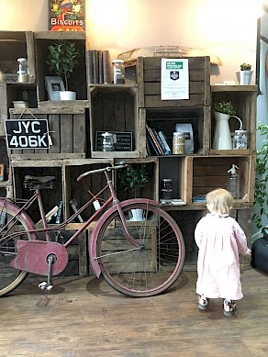
"I love going to the Roastery cafe in Quedgeley with my girls. We often meet up with friends in this modern, cosy cafe and it never disappoints. As well as making a great cup of coffee and always having a superb collection of cakes, it has lots of space for pushchairs and baby changing facilities. They are very accommodating of little ones, and the staff will often make the effort to have a little chat with my daughter, as she plays/eats cake!! As if that wasn’t enough they do a fabulous kids hot chocolate! Oh and they also have a convenient, free car park."

Local mum of one Jess, who blogs at JesstheStar, loves taking her daughter to The Q Club in Quedgeley, a brilliant family-friendly cafe in Gloucester with soft play!
"The Q Club in Quedgeley has been one of my favourite places to visit with my small person. The soft play area is the ideal place for sitting with a hot drink while your toddler uses up some of their boundless energy. They even have a small and enclosed baby area so it really caters for littler ones too. On better weather days there is also an outdoor play area to entertain them. The manager, Richard, is so welcoming and friendly plus he makes a mean cappuccino and always has some yummy cakes on offer."
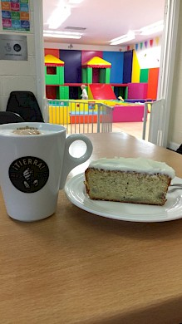

Gloucestershire based mum of two Danni enjoys spending a few hours at super family-friendly Gloucester Services, M5 (between J11a and 12).
But the best is yet to come with Gloucester services. Once you’ve eaten your lunch/cake or just had a coffee, the little ones can play in the fantastic natural wood indoor play area. Complete with slides, climbing walls, bridges (depending on which side of the motorway you’re on), the kids are entertained and all for free. It’s not your average soft play, that’s for sure. They do also have an outdoor play area, but we haven’t ventured that far yet."

