

Early Help Newsletter Gloucester: May 2020

Hello All,
This month’s edition of the early help newsletter focus’s on sleep. On Monday 18th May to Sunday 24 May 2020. The campaign theme for Mental Health 2020 is 'sleep'. The week will focus on the connections between our sleep - or lack of it - and mental health.
Kindest regards
Emma, Hayley, Laura and Lisa (Early Help Coordinators Gloucester)

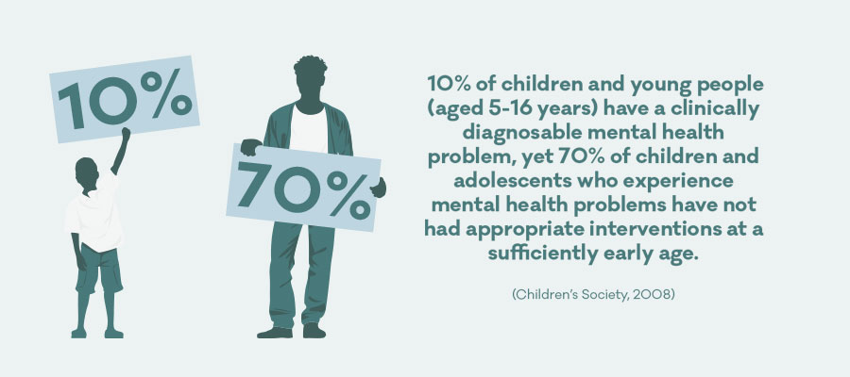
It is estimated that almost a third of the population will experience problems sleeping at some point in their lives, yet there is no doubt that a lack of sleep can have a profound effect on your mental well-being.
The long term impact of poor sleep can lead to feelings of depression, anxiety and can lead to increased feelings of isolated and physical fatigue. For people living with severe mental illness, such a schizophrenia and psychosis, a lack of sleep can increase the symptoms of manic and paranoia.
A lack of sleep can lead to:
- Low mood
- Anxiety
- Elevation in blood pressure and stress hormones.
- Poor cognitive functioning
Sleep is as important to our health as eating, drinking and breathing. It allows our bodies to repair themselves and our brains to consolidate our memories and process information.

Why are teens always tired?

Trouble getting up on school days, dozing off in class, marathon lie-ins at weekends... It may feel like your teenager is sleeping their life away. In fact, the opposite is probably true. Sleep experts say teens today are sleeping less than they ever have.

This is a worry, as there's a link between sleep deprivation and accidents, obesity and cardiovascular disease in later life. Lack of sleep also affects teenagers' education, as it can leave them too tired to concentrate in class and perform well in exams.

Our sleep patterns are dictated by light and hormones. When light dims in the evening, we produce a chemical called melatonin, which tells us it's time to sleep.

The problem is that modern life has disrupted this pattern. Bright room lighting, TVs, games consoles, mobiles, tablets and PCs can all emit enough light to stop our bodies producing melatonin. On top of this, research suggests that teenagers' body clocks are set later than adults' and younger children's. In other words, they're programmed to stay up later, and also get up later, than the rest of us. This would not be a problem if your teenager did not have to get up early for school.

These early morning wake-up times mean they're not getting the 8 to 9 hours of sleep they need. The result is a tired, cranky teenager.

Tips for better teen sleep
Catching up on sleep at weekends is not ideal. Late nights and long lie-ins will just disrupt your teenager's body clock even more. However tired they feel, teenagers should avoid lie-ins at the weekend. They should also get out into the daylight during the day.
Both these things will help to keep their body clock regular, and make it easier to go to sleep and get up at a reasonable time.
See more sleep tips for teenagers.

Getting help for sleep problems
Your GP can give your teenager advice on sleep problems and, if necessary, recommend a sleep clinic.
Sleeping all the time can sometimes be a sign of depression – see Is your child depressed? See some other medical reasons for feeling tired


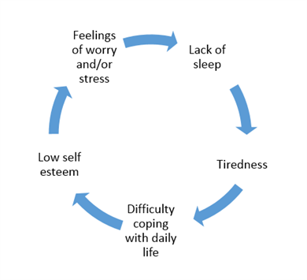
"Poor sleep leads to worrying. Worrying leads to poor sleep. Worrying about sleep is like your mind trying to fight itself. That's a horrible place to be."
"For me sleep problems are a tell-tale sign of declining mental health. The worse I sleep, the less I feel able to cope during the day. The less I am coping, the worse I seem to sleep."
"You can't 'switch off', and you're pleading with your brain to just give you a break, just for a few hours, at least."
"I avoid my phone or TV – instead I listen to a meditation podcast or read a book."
"When I'm suffering from sleeping problems it's usually the result of not getting enough physical exercise and staying in bed."

Night terrors and nightmares
Many children experience nightmares and night terrors, but most grow out of them. They don't cause any long-term psychological harm to your child. Night terrors are very different from nightmares.

A child having night terrors may scream and thrash around, and may not recognise you if you try to comfort them.
This behaviour occurs on waking abruptly from deep, non-dream sleep. Your child won't be fully awake during these episodes and will have no memory of it the next morning. Nightmares occur from dream sleep (REM sleep). Your child may wake up from the nightmare and, depending on their age, may be able to remember and describe the bad dream to you. Both night terrors and nightmares in children are described in more detail below, along with advice about what you should do.

Night terrors
Night terrors are common in children aged between 3 and 8 years old. A child who experiences night terrors may scream, shout and thrash around in extreme panic, and may even jump out of bed. Their eyes will be open, but they're not fully awake.
The episodes usually occur in the early part of the night, continue for several minutes (up to 15 minutes), and sometimes occur more than once during the night.

Why they happen
Night terrors are more common in children with a family history of night terrors or sleepwalking behaviour.
A night terror attack may be triggered by anything that:
increases how much deep sleep your child has, such as tiredness, fever or certain types of medication
makes your child more likely to wake from deep sleep, such as excitement, anxiety, sudden noise or a full bladder

What you should do
The best thing to do if your child is having an episode of night terrors is to stay calm and wait until they calm down.
Don't intervene or interact with them, unless they're not safe. Night terrors can be frightening to witness, but they don't harm your child. You shouldn't attempt to wake your child when they're having an episode. They may not recognise you and may become more agitated if you try to comfort them. Your child won't remember the episode the next morning, but it may still help to have a general chat to find out if anything is worrying them and triggering the episodes. It'll also help if they have a relaxing bedtime routine.
Try not to discuss the episodes with your child in a way that worries them as this may increase their anxiety.

If the night terror episodes are frequent and occur at a specific time every night, you may find that waking your child breaks the cycle.
Wake your child 15 minutes before the anticipated time of the episode every night for 7 days.
This can disrupt their sleep pattern enough to stop the episodes without affecting sleep quality.

When you should seek help
Most children eventually grow out of night terrors. But talk to your GP if they're occurring several times a night or most nights.
Your GP will be able to check whether something that's easily treatable is causing the episodes.
For example, large tonsils could be causing breathing problems at night and waking your child.
In a small number of children who have frequent episodes of night terrors, referral to a specialist service may be needed.

Nightmares
Nightmares are common in children aged 3 to 6 years old. Most children grow out of them.
Nightmares usually occur later in the night and cause strong feelings of terror, fear, distress or anxiety.
Your child may wake up and be able to remember and describe the dream to you.
Nightmares in children can be caused by a frightening experience, such as watching a scary film, or by something that's worrying them.

What you should do
Talk to your child to find out whether anything is worrying them that could be triggering their nightmares.
As with night terrors, making sure your child has a relaxing bedtime routine will also help.
Take your child to see your GP if they're having repeated nightmares (a series of nightmares with a recurring theme).
If your child's nightmares are being caused by a stressful past experience, they may need counselling.

https://www.nhs.uk/conditions/night-terrors/

Routine, routine, routine. Preparing your brain and body for sleep, letting yourself know that it's time to wind down. Then in the morning set a time to get up and stick to it no matter what."

Relax before you go to bed
You may find a relaxation routine can help you prepare for sleep. There are several things you can try:
- Do something calming – such as listening to relaxing music, or having a bath.
- Breathing exercises – in a comfortable position, try this: breathe into your belly (not your chest) then out through your nose, making your out-breath longer than your in-breath; repeat until you feel relaxed.
- Muscle relaxation – consciously tense and relax your muscles, one after the other, starting with your toes and working up your body until you reach the top of your head;
- Progressive Muscle Relaxation is a technique some people find useful – this NHS guide has further details.
- Visualisation – picture a scene or landscape that has pleasant memories for you.
- Meditation – you can learn meditation techniques at a class or from self-help guides; many people also find mindfulness helpful.

Make sure where you sleep is comfortable
You may want to experiment with the temperature, light and noise levels to work out what works best for you. On the whole, dark, quiet and cool environments generally make it easier to sleep, but this will vary from person to person.

Keep a sleep diary
You may find it difficult to work out what's affecting your sleep. A sleep diary involves recording information about your sleep habits to help you understand your sleep problem and what's affecting it. If you want to, you can show it to professionals you're working with, so you can work together to understand the problem you're having.

A sleep diary could include information about:
- what time you go to bed and what time you get up
- total number of hours of sleep
- overall quality of sleep, ranked 1–5
- how many times you wake up in the night, how long you are awake and what you do while you are awake
- whether you have nightmares, night terrors or sleep paralysis, or have sleepwalked during the night
- whether you sleep during the day, and for how long
- any medication you're taking, including dose and what time you take it
- the amount of caffeine, alcohol or nicotine you have
- the amount of physical activity you do
- what you eat and drink
- your general feelings and moods, including any anxious and repetitive thoughts.
- You can create your own diary using an online template – there's an example on the NHS Choices Live Well website.
Give yourself some tech-free time
Use of bright screens on laptops and phones in the evening has been shown to negatively affect sleep.
Try to give yourself some tech-free time an hour or so before bed, to help yourself prepare for sleep.

Food, drink and exercise
Caffeine, alcohol and sugary foods may give short-term help but they can all disturb your sleep patterns. For details see our information on food and mood.
Doing regular physical activity can also help you sleep, as it makes you more physically tired – particularly if you exercise outdoors. This doesn’t have to be strenuous exercise – any activity, for example housework, gardening or going for a walk, can help. See our information on physical activity, sport and mental health.

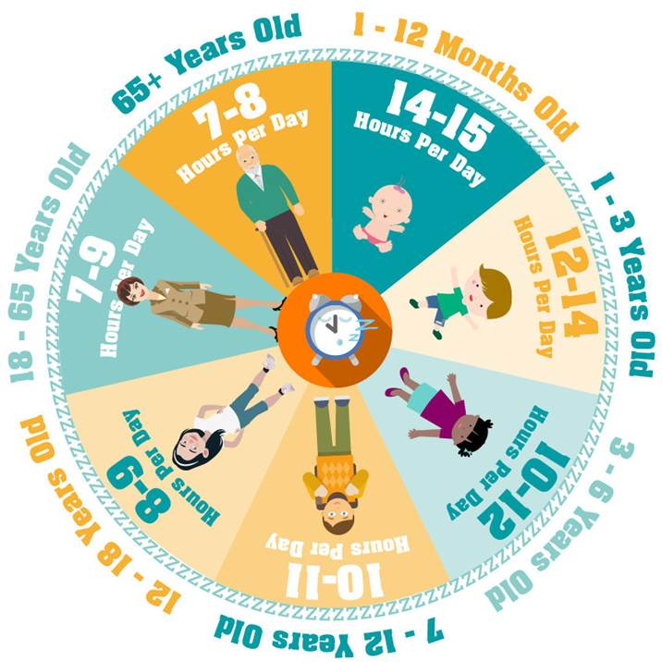

What helps our Ambassadors sleep:-
‘Go out for a run’ Abie, Ambassador for vulnerable children & young people
‘I listen to the Calm App which has white noise to stop me thinking’ Tee Ambassador for vulnerable children & young people
‘ I wear an eye mask to block out the light, and I sometimes use lavender to help me sleep. Listening to an audiobook can help too’ Tamara Ambassador for vulnerable children & young people

Useful Websites:
https://www.mentalhealth.org.uk/publications/sleep-report
https://www.mentalhealth.org.uk/blog/ten-top-tips-good-sleep
https://www.mentalhealth.org.uk/publications/how-sleep-better
https://www.nhs.uk/oneyou/every-mind-matters/sleep/#what-is
https://www.mind.org.uk/information-support/types-of-mental-health-problems/sleep-problems/sleep-problems/
https://www.nhs.uk/live-well/sleep-and-tiredness/how-much-sleep-do-kids-need/

Helplines and services available
YoungMinds Crisis Messenger
- Provides free, 24/7 crisis support across the UK if you are experiencing a mental health crisis
- If you need urgent help text YM to 85258
- All texts are answered by trained volunteers, with support from experienced clinical supervisors
- Texts are free from EE, O2, Vodafone, 3, Virgin Mobile, BT Mobile, GiffGaff, Tesco Mobile and Telecom Plus.
Samaritans
- www.samaritans.org
- If you're in distress and need support, you can ring Samaritans for free at any time of the day or night.
- Freephone (UK and Republic of Ireland): 116 123 (24 hours)
- Email: jo@samaritans.org
Childline
- www.childline.org.uk
- If you're under 19 you can confidentially call, email, or chat online about any problem big or small
Freephone 24h helpline: 0800 1111
- Sign up for a childline account on the website to be able to message a counsellor anytime without using your email address
- Chat 1:1 with an online advisor
The Mix
- www.themix.org.uk
- If you're under 25 you can talk to The Mix for free on the phone, by email or on their webchat. You can also use their phone counselling service, or get more information on support services you might need.
- Freephone: 0808 808 4994 (13:00-23:00 daily)

Seek NHS support
If poor sleep is affecting your daily life or causing you distress, call NHS 111 or talk to your GP.
- NHS advice about sleep and tiredness
- Try the NHS sleep self-assessment
- NHS self-help guide: sleep


Wetting the bed
Bedwetting can cause young people to wake up in the night. This might have a physical cause or be linked to worries and anxiety. Talk to your GP who can advise you about getting help

Altered sleep problems
If you tend to push boundaries and stay up late watching TV, gaming or staring at your phone or tablet screen, this may alter your sleep patterns. It’s not uncommon for teenagers to reverse their sleeping patterns, staying awake late into the night and then feeling sleepy during the day. This can interfere with school work and home life, and cause stress with parents. Have some screen-free wind-down time (reading a real book is ideal) before going to bed at a reasonable time each night.

Get help
Chat to your GP if your sleep problems continue for a long time, things you try at home are not helping, or if you are worried about an emotional or physical problem. Severe sleep problems can be a sign of depression. Young people with attention deficit hyperactivity disorder (ADHD) may also have problems with sleep.

Dealing with exam stress
It is normal to feel a bit worried about exams, especially if you're under pressure from school or family. Exam stress can cause you to feel anxious or depressed, and this might affect your sleeping or eating habits. If you recognise any of these feelings, or are worried that exam pressure is taking over your life, you are not alone, and there are things you can do:
- Let your trusted friends and family know if you are struggling, so they can be there to support you, encourage you and offer a listening ear. You don't have to go through this alone. Keeping it all in will only make things worse in the long run, so don't be afraid to open up.
- Ask for help. Think about all the practical support you need, and be honest with yourself about it. You are allowed to ask for help. Talk through your concerns with your teacher/tutor who can let you know what support your school, college or uni can offer you. They will have spoken to lots students before who are going through similar things, and they are likely to know about helpful resources or services available to you.
- Try finding a study group, or start your own. Working through problems with other students can be a nice way to keep your social life going and boost your morale.
- Be kind to yourself. Think about all the things you have achieved so far. It can be helpful to write a list of all the things you like about yourself, and the things other people value about you too.

If people around you, like your parents or family, are putting pressure on you, it can help to tell them what you feel able to achieve, and let them know that your expectations are different to theirs. You could also talk to a teacher you trust about the pressure you are under at home.

Mental Health Support Services
Rethink Mental Illness – Self Harm Support  0808 801 0606  Or text 07537410 022  http://www.gloucestershireselfharm.org  or  www.rethink.org | Our Gloucestershire Self Harm Helpline provides a safe, supportive, non-judgmental and informative space for people who self harm, their friends, families and carers. We also speak to professionals who may want to know more about self harm. The service is able to support anyone living within Gloucestershire, and you can contact the service by telephone, text or webchat during our opening hours, every day 5pm to 10pm.

01452 24533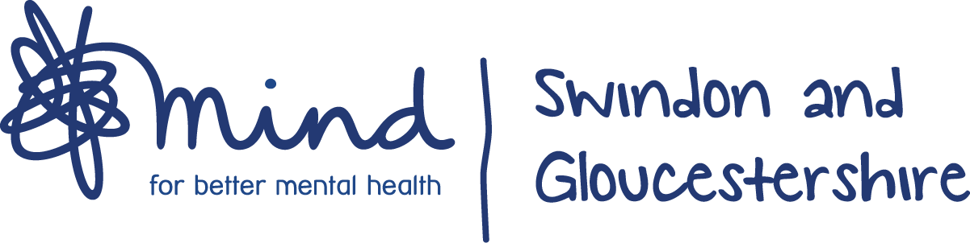8  www.sgmind.org.uk  or email  alexwellbeing@sgmind.org.uk | We provide advice and support to empower anyone experiencing a mental health problem. We campaign to improve services, raise awareness and promote understanding. We won't give up until everyone experiencing a mental health problem gets support and respect.  www.mind.org.uk – this website provides an A – Z of mental health topics.
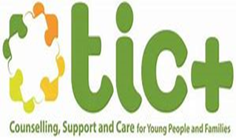www.ticplus.org.uk  01594 372777  Or text  07520 634063  Parent Support & Advice line offers online chat  0800 6525675  https://ticplus.org.uk/parents-carers/parent-and-carer-support/ | Online or telephone counselling for children and young people  At TIC+ we’re here to support children and young people aged 9-21 and their families.
www.ghc.nhs.uk/crisis  0800 169 0398 | NHS online services available to support with mental health.
https://www.onyourmindglos.nhs.uk/  | We found that children and young people want to know what help and support is available to them locally and nationally. They want to know how they can help themselves and which websites they can trust. That is why we have created the ‘On your mind’ website. We hope that this website will mean that you are able to get help when you need it and also do things to make yourself stronger, so you are more able to cope when things are tough.
www.samaritans.org/branches/gloucester/  116 123 (free)  Or  0330 0945717 (Local Rate) | Whatever you're going through, a Samaritan will face it with you. We're here 24 hours a day, 365 days a year.
  https://www.infobuzz.co.uk/mental-health/  01452 501 008 | Infobuzz offer a range of services to support people to improve their mental health. Hover over the mental health banner in the menu above to see a full list of services available. Or please get in touch to discuss specific needs

 Young Gloucesterhire  https://www.youngglos.org.uk/young-people/mental-health/linked-up-project  01452 501008  Email hello@youngglos.org.uk | You might not be sure if you need help with your 'mental health', you might just be feeling a bit blue or overwhelmed. Or perhaps you have received a diagnosis and you don't know what happens next. Linked Up is able to offer practical and emotional support.  The project works with 16-25 year olds facing challenges with their mental and emotional wellbeing. If your mental health is starting to have an impact on your day-to-day life, it may be a good time to get in touch.
SHOUT  https://www.giveusashout.org/  Text Shout to 85258 | Shout is the UK’s first 24/7 text service, free on all major mobile networks, for anyone in crisis anytime, anywhere. It’s a place to go if you’re struggling to cope and you need immediate help.  Shout is powered by a team of volunteers, who are at the heart of the service. We take people from crisis to calm every single day.
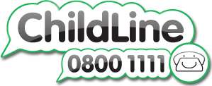 | A message from Childline  It can be difficult to cope when there’s so much changing around us. You might be worried about schools closing, friends or relatives getting ill or what'll happen in the future.  Childline and our counsellors want to support you through this. We’re working hard to make sure you can still speak to a counsellor when you need to.
  https://www.themix.org.uk/get-support  or  0808 808 4994 | The Mix are always here to help young people with any issue they’re facing, and at this challenging time, our services are more needed than ever
https://youngminds.org.uk | We’re leading the fight for a future where all young minds are supported and empowered, whatever the challenges. We’re here to make sure they get the best possible mental health support and have the resilience to overcome life’s difficulties.
  https://papyrus-uk.org | HOPELINEUK is a confidential support and advice service for:  - Children and Young People under the age of 35 who are experiencing thoughts of suicide  - Anyone concerned that a young person could be thinking about suicide

https://www.annafreud.org   | The Anna Freud National Centre for Children and Families is a children’s mental health charity with over 60 years’ experience of caring for young people and their families. Our vision is a world in which children and their families are effectively supported to build on their own strengths to achieve their goals in life.
https://www.bigwhitewall.com | People come to Big White Wall for support with a wide range of mental health and wellbeing issues – from anxiety, depression, isolation and stress, to relationship problems and lifestyle challenges. The safety of our members and clinical rigour is at the core of what we do and we have a network of trained professionals providing 24/7 support around the world
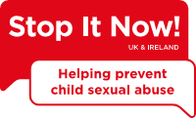https://www.stopitnow.org.uk/  or  call 0808 1000 900 (9am-9pm Monday-Thursday, 9am-5pm Friday). | Our confidential Stop It Now! Helpline is available to anyone with questions or concerns about child sexual abuse prevention, including parents and professionals
The Music Works https://www.themusicworks.org.uk/young-person/mental-health/ | Music can have a massive impact on your state of mind. For many people, it can help them to cope with stressful times and with mental health problems like depression and anxiety
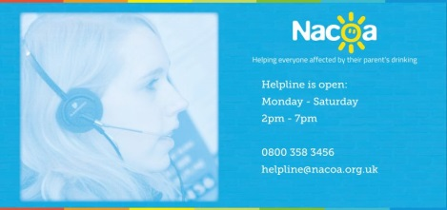https://www.nacoa.org.uk/  0800 358 3456 | Providing information, advice and support for everyone affected by a parent's drinking
https://www.thedoor.org.uk/ | The Door's mission is to bring hope into the lives of young people and their families, through unlocking potential and opening opportunity so their past does not define their future.
Mindfulness Apps  - Headspace  - Calm  - Smiling mind  - Mindfulness daily | Top 20 apps for Kids: https://mindbe-education.com/top-20-mindfulness-apps-kids/  Young people & anxiety App: https://healthyyoungmindspennine.nhs.uk/resource-centre/apps/

